Winter 2017-2018
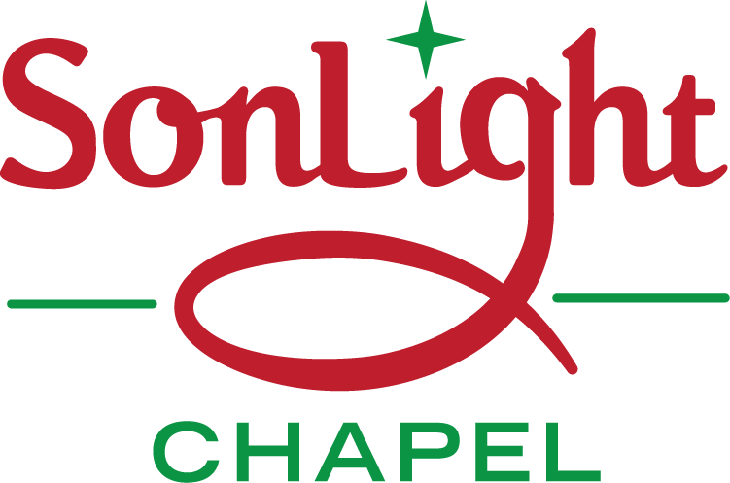
Neighbors Warming Neighbors

CHRISTMAS WREATH SALE
A $15.00 DONATION FOR NEIGHBORS WARMING NEIGHBORS
Saturday, December 9, 2017 between 9am and 2pm
At our new church location at 53 Main Street, Felton, PA
Baked goods will also be available inside the church building.

Purpose – to collect funds to help our neighbors in our local area meet the costs of their winter 2017-18 home heating. Also to distribute those funds to the neighbors who have the greatest need for assistance. Last year $1645 was collected and it was used to help 11 neighbors with their winter heating costs.
Donations – Cash or checks made out to “SonLight Chapel”
NAME_______________________
# OF WREATHS________________
DONATION AMOUNT___________

To pre-order: Return this order form or contact us at: 717-927-6261 by Dec 2.
