Prayer and
CHANCEFORD AREA
COMMUNITY

Meets every Friday from 9:30-11AM
at the Chanceford Community Building and we need YOU!
****** CURRENTLY STUDYING ******
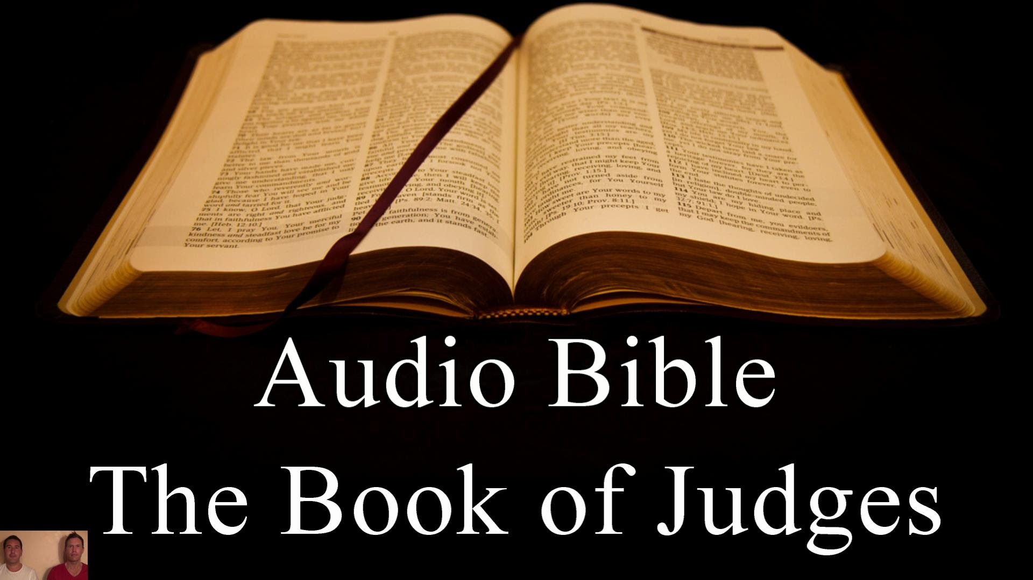

and led by Jean Miller Phone: 717-927-6261
This Bible Study is sponsored by:

