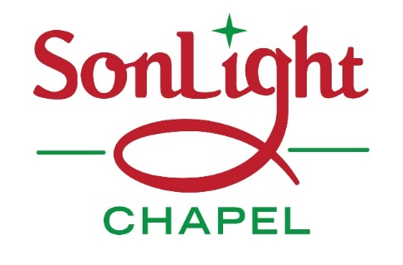

**2018**

**Christmas Services**

**Christmas**

**Eve**

**53 Main Street, Felton**

**Church: 717-501-5320**

**Office: 717-927-6261**

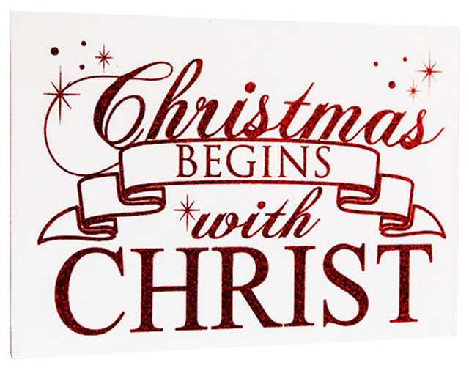



**Sunday December 2, 2018 at 10:00am – Focus on the gift of HOPE**

**“There shall be a root of Jesse…..and He shall rise to reign.” Romans 15:12**



**Sunday December 9, 2018 at 10:00am – Focus on the gift of PEACE**

**“His name shall be called….Prince of Peace.” Isaiah 9:6**



**Sunday December 16, 2018 at 10:00am – Focus on the gift of JOY**

**“Behold, I bring you good tidings of great joy.” Luke 2:10**



**Sunday December 23, 2018 at 10:00am – Focus on the gift of LOVE**

**“For God so loved the world that He gave His only begotten Son.” John 3:16**



**Monday December 24, 2018 at 7:00pm – Focus on the gift of LIGHT**

**“I am the Light of the world.” John 8:12**

**During this entire Christmas season SonLight Chapel is collecting paper towels**

**and toilet paper for LifePath Christian Ministries in York. Donations may be**

**dropped off at the church anytime between now and the end of 2018.**