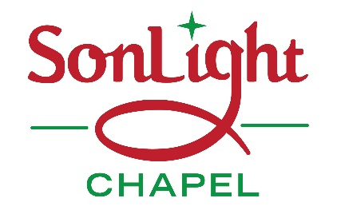
2018 Christmas Banquet
Date: Saturday December 8, 2018
Time: 4:00pm

Location: Chanceford Township Community Building
(the old Chanceford Elementary School)
33 Muddy Creek Forks RD, Brogue PA

Menu: Turkey& Venison Dinner with all the trimmings

Cost: $5.00 for all ages
For tickets - contact
Sue Miller at 717-927-9451 by Dec 1st

