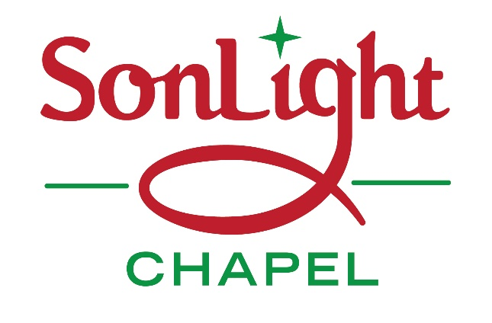
Saturday December 8, 2018 from 8:00Am – NOON
53 Main Street, Felton
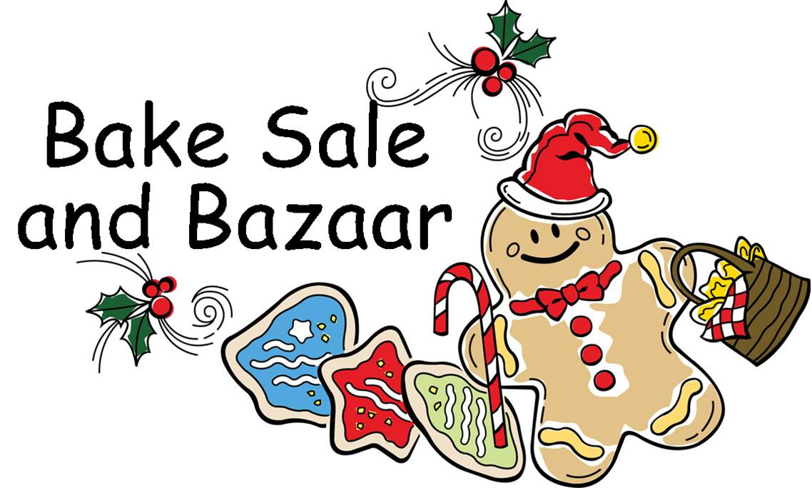

Featuring:
Raffle Items
Handmade Christmas Cards
Wooden craft Christmas items

“Christmas Begins with Christ” theme items - and much more!
Monies received will benefit our “Neighbors Warming Neighbors” program, which provides heating assistance to local families during the cold winter months. Over $7000 was given to assist families since this program began.

Coupon can be redeemed for
ONE FREE PLINKO prize at
SonLight Chapel’s Christmas Bazaar
On December 8, 2018 from 8AM - NOON

Contact us at 717-501-5320 or see us on Facebook.

