SonLight Chapel of 53 Main Street in Felton is collecting food items at the April 6th 2019 Chanceford Area Business Showcase for Community REACH of Red Lion for their Summer Kids Kafe program. This program provides food over the summer months to children in need from the Red Lion, Eastern, and Dallastown school districts.

All items being collected should be individual serving size and non-refrigerated. Please donate items with expiration dates posted after July 2019. The specific items needed:

Snack packs- canned chicken salad or tuna salad with crackers

Pudding cups Non-refrigerated Jello cups

Juice boxes Individual sized cereals

Fruit cups Individual sized shelf stable milk

Small boxes of raisins Mac & Cheese cups

Trail bars Cheese or peanut butter crackers

Small packs of popcorn, cookies or other healthy snacks
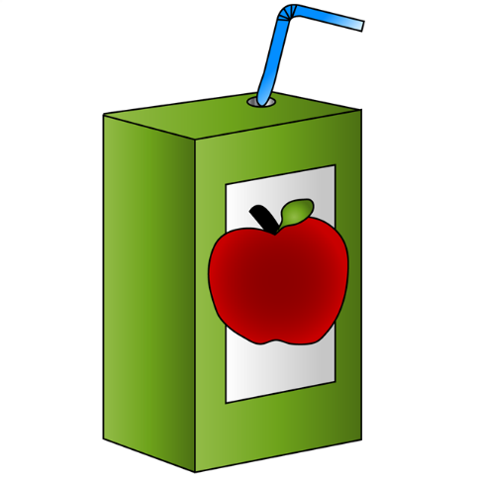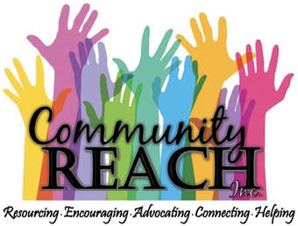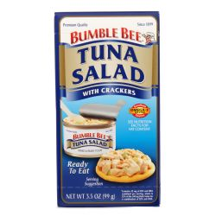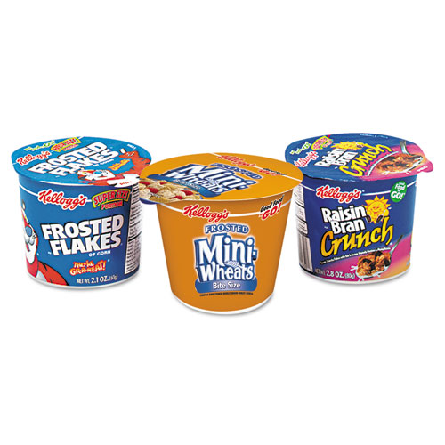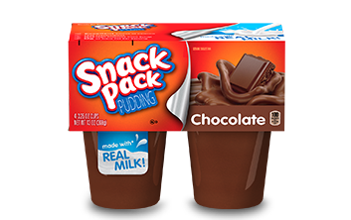

As an alternative way to give – A $12.50 donation provides 1 lunch bag for 1 child for the whole week.

Please contact Susan Miller @ 717-927-9451 if you have questions about this mission project.

