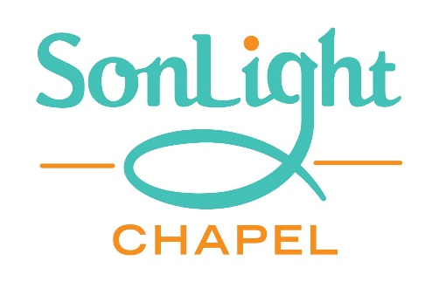
53 Main Street
Felton, PA
2019 Adult VBS Class:
“Discovering and Using Your Spiritual Gifts”
Wednesdays July 10, 17, 24, 31 and August 7
From 7:00 till 8:00pm
Learn about:
23 Spiritual gifts
Which ones did God give to you?
Biblical examples
Combining personalities and spiritual gifts
Interested in this fun and enlightening class?
Contact Jean Miller as soon as possible so that we have adequate supplies on-hand.
Phone 717-927-6261

